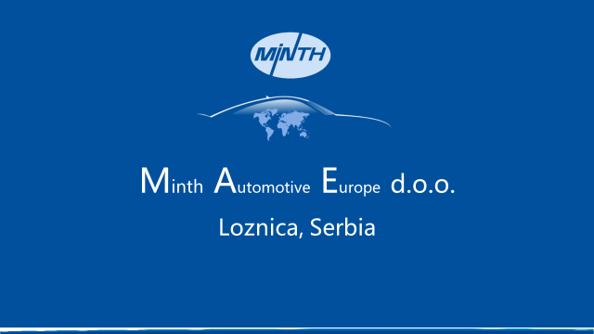MINTH is Auto Parts Company with headquarters located in China. With more than 16 000 employees in 43 production facilities around the world, MINTH is a leading global supplier in design, manufacturing, and sales of body structural parts, trims and decorative parts of passenger vehicles. MINTH supplies to many world-renowned international automakers. Together, MINTH's customers represent 80% of the total global auto market share. And in 2018, Minth set up new manufacturing plant in Serbia.
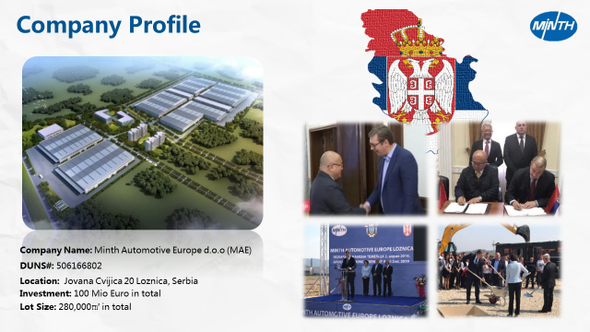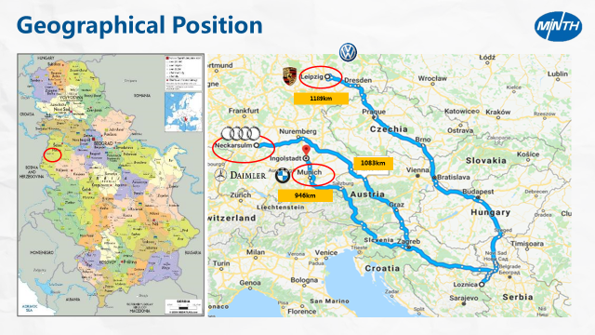
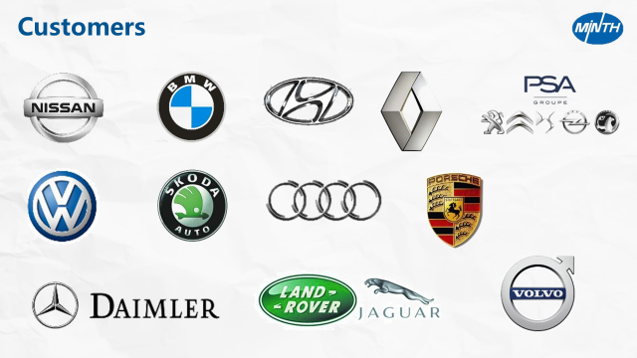
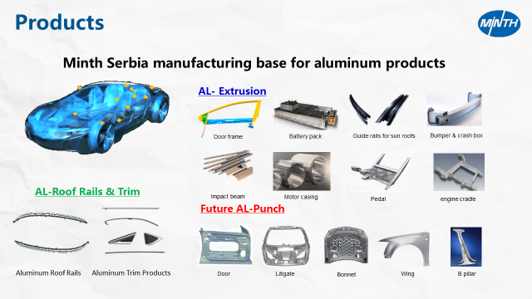
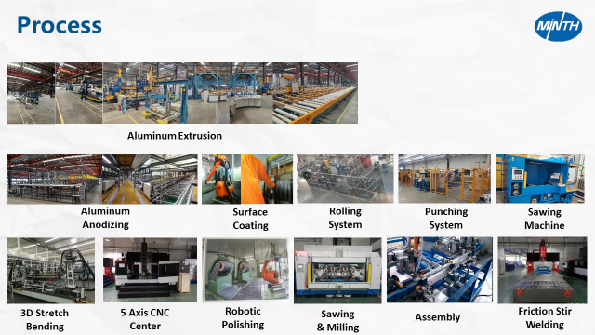
And now, we are looking for good candidates for the position as below:
- Job Title: Mold Design Engineer (1 person)
RESPONSIBILITIES:
• Evaluate the new project including drawings proofing and previous risk assessment.
• Responsible for new project mold development and risk assessment.
• Responsible for new project mold purchase request, delivery follow-up, test production, and get consensus of result with project management function.
• Responsible for mold purchase request, adjust mold inventory numbers according production plan, and improve the defect.
• Responsible for mold solution and lesson learned to problems.
• Responsible for mold management system and continual optimization.

BASIC REQUIREMENTS:
• Bachelor degree and above
• Interested in mechanical or mold design, manufacturing, maintenance and management experience.
• English will be used as a working language
• Proficient in knowledge and skills of mold design, manufacturing, maintenance and software application;
• Familiar with project management and mold management;
• Acquired production technology of last and next process.

- Job Title: Extrusion Process Engineer (1 person)
KEY RESPONSIBLITIES:
• During the launch of new product, be responsible for the extrusion drawing review and the specification review.
• Be responsible for the extrusion process design, including the BOM, Process Flow Chart, Cost assessment form, etc.
• Adjust the extrusion and aging specifications, calculate and update the cycle time;
- On sample delivery, be responsible for standardization of the process technics and give training to the operators;
- Tracking the quality of the new product, adjust the technics to meet the quality requirement;
- Solve any technics issues during production;
- Optimize the technics to improve work efficiency.

BASIC REQUIREMENTS:
- Bachelor’s degree or above, majored in Metal Material, Mechanical relevant, etc.
- Interested in extrusion process;
- Have knowledge about extrusion product test, inspection and Mechanics Performance Testing is preferred.
- Have knowledge about IATF 16949, SPC、MSA、FMEA、APQP、PPAP;
- Good command of English, can use English as working language.

- Job Title: Packing Design Engineer (1 person)
Position Description:
We are currently looking for a Packing Design Engineer to join our team. This position is responsible to design packing solutions for parts during transportation.
In this role, you are expected to be:
- Responsible for feasibility assessment and packaging design for parts in the plant.
- Responsible for packaging production for new products as well as for provision of trial packaging for some small series
- Send the customers a packaging design plan
- Responsible for monitoring and supervising the quality of packaging, delivery, as well as for the proper use of packaging
- Taking care about reduction of packaging costs
- Improvement of the packaging for mass-produced products

Following qualifications and abilities are expected for this role:
- Bachelor degree and above, major in Mechanical and Industrial design is preferred;
- Good knowledge of English is required due to daily communication with foreign buyers and suppliers;
- Skillful in 3D design tools like UG10.0 or PRO-E, or solidworks and catia and in AutoCAD.
- Job Title: Project Engineer (2 persons)
RESPONSIBILITIES:
• Responsible for new project development, give support to business department to do preliminary engineering analysis of new tender product, and conduct new project feasibility assessment;
• Coordinate new technology development and standardization with R&D department;
• Conduct project preliminary planning, project task assignment, development progress tracking and reporting, and making product development files.
• Monitor the project schedule, control the key points in product development process
• Coordinate cost management of new product development with Finance Dept.
• Keeping and improving customer relationship
• Responsible for mass production technology management, including controlling and updating technology requirement and files, solving quality problems from clients or site, and promote product integrative competence

BASIC REQUIREMENTS:
• Bachelor degree and above
• Good English ability in listening, speaking, reading and writing as a work language
• Proficient in Office software and project management knowledge and skills;
• Familiar with Microsoft Project, CAD software, MSA and SPC;
• Good in communication and is willing to work as Project Engineer

If you’re interested to our position, please contact us through: li.bian@minthgroup.com.
Looking forward to your information!

